**Your Name: Purnabhishek Sripathi**

**Grading Policy: In order to get credit for each screenshot,** you **MUST** have the repository named as ***BAN540_YourLastName*** with ***Chapter09DataSet_Training_YourLastName, Chapter09DataSet_Scoring_YourLastName*** and ***BAN540_Lab4_YourLastName*** in it. The repository and data files **MUST** be clearly shown in your screenshot as my examples below. you will get ZERO for that particular screenshot which doesn’t show them clearly.

**Note:** “YourLastName” in this document refers to your own last name. Don’t literally type in “YourLastName” to name any of your repositories/processes/dataset files.

**Screenshot #1 (10 points)**

**Screenshot #2 (10 points)**

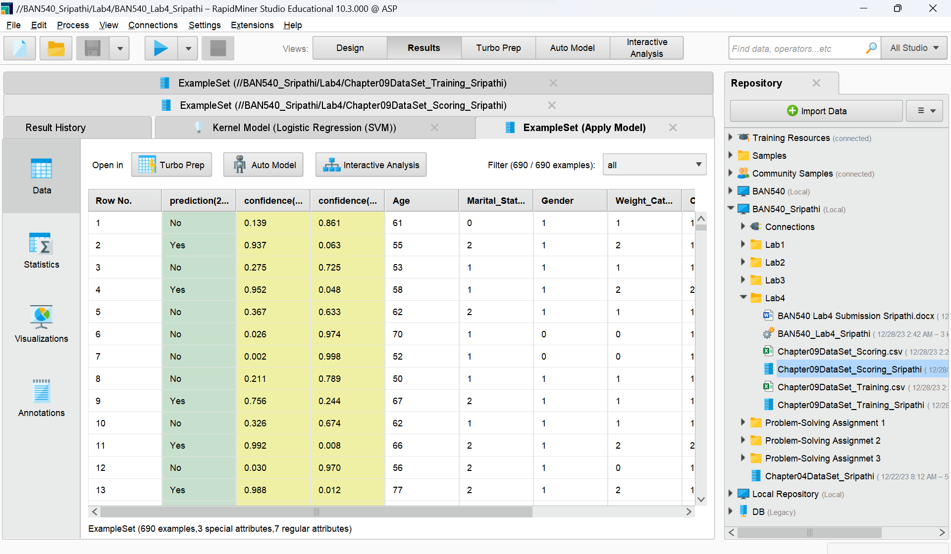

**Screenshot #3 (5 points)**

**Screenshot #4 (5 points)**

**Now you are done with Lab Assignment 4, please make sure to fill in your name on the first page of this document and rename this document to reflect your own last name before submitting it to Canvas.**